**Soilmate**

**Developer’s Guide**

Collaboratively Written

Version 1.0

February 21, 2014

Travis Andrews

Ian Field

Daniel Mason

Jerad Mason

Kerry Kergan

**Revision History**

**Date of next revision:** March 7, 2014

|  |  |  |  |
| --- | --- | --- | --- |
| **Revision Date** | **Previous Revision Date** | **Summary of Changes** | **Version** |
| Feb. 21, 2014 | NA | Initial Developer’s Guide | 1.0 |
|  |  |  |  |
|  |  |  |  |

Table of Contents

**page**

1. **Architecture**__________________________________________________3
2. **Activity Diagram**_______________________________________________4
3. **Design Model**_________________________________________________5
4. **Domain Model**_________________________________________________6

Architecture

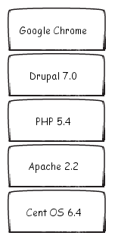

Activity Diagram

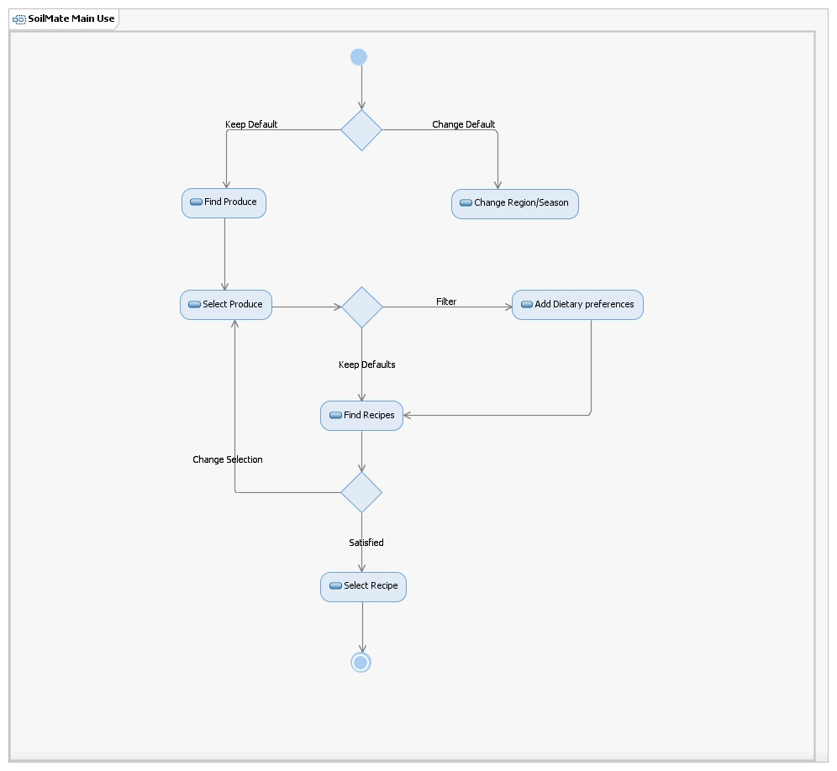

Design Model

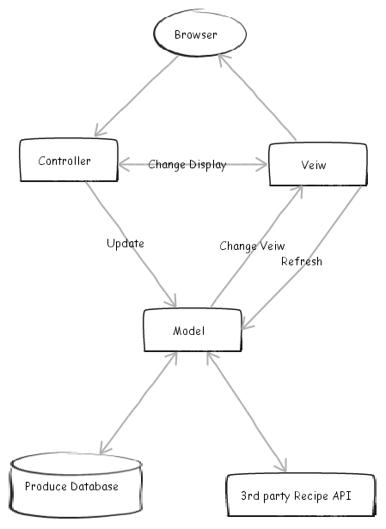

Domain Model

